Computational Analysis of Deafened Cricket Behavior
Student Researcher: Kate E. Walsh Advisor: Hadley Horch
Bowdoin College
Department of Neuroscience
Abstract
The cricket auditory system demonstrates an unusually high degree of neuronal plasticity. When crickets are deafened (deafferented) on one side, neuronal growth is triggered, resulting in new connections with auditory input from the ear on the opposite side. These new connections presumably allow a variety of compensatory behavioral responses from the crickets, affecting aspects of flight behavior such as changes in angle of rotation to avoid the source of the predator call and the twitch/jerk response of the cricket at the onset of sound stimulation. In order to quantify and characterize these differences in behavior, I utilized a behavior tracking program called DeepLabCut to analyze footage of crickets in a simulated predator situation. By collecting data on the trajectory of flight for these crickets, as well as investigating the degree of response immediately following the sound stimulus and after habituation, we can begin to track behaviors across crickets, including those who have different biological reactions to deafferentation (e.g., differences in structural plasticity).

Project Objectives
Novel machine learning programs have changed the way behavioral scientists approach the characterization and quantification of animal behavior. Using a computational behavior tracking program called DeepLabCut (Mathis et al. 2018), I was able to train a network to recognize body parts on a cricket from sample frames of video. Once the network was trained and retrained to recognize these body parts, I was able to use the network to analyze new footage of crickets. The information sourced from this program included the trajectory throughout the simulated flight of the cricket, the amount of traceable reaction from the cricket based on time from the presentation of the audio stimulus, and the twitch of the cricket (referring to the jerk-like movements of the cricket legs and other body parts that does not directly related to turning away from the predator call).
Due to COVID-19, I was not able to go into the lab on campus in order to take my own footage of simulated cricket flights under my own experimental conditions. Instead, I used my DeepLabCut network to analyze footage from the Horch lab, specifically Holly Wadman’s honors thesis, from 2014. The data collected from my research in part supplemented the behavior quantification that she did by hand, as well as contributed to a collection of data that is being used in conjunction with Professor Jack O’Brien’s statistics research group to quantify a large “feature space” of cricket behavior.

Methods
Cricket Flight Simulation and Footage: The footage used for my analysis consisted of simulated flight behavior in a box. The crickets were waxed to a screw and suspended from the middle of a sound insulated box. With a fan and a rectangular hole in the back of the box, a laminar airflow was generated to induce flight. Speakers were fixed at a 90 degree angle on either side of the cricket in the box in order to experimentally mimic the call of a bat from either side of the cricket at adjustable decibel levels, in this case with the sound files being played at 75 dB. In order to elicit the predator evasion, or negative phonotaxis, behavior from the cricket, pulses of sound at 20 kHz were played for 50 milliseconds with 50 milliseconds of silence between pulses. This file was played for 5 seconds on either side of the cricket with 20 seconds of silence between plays, with this pattern of alternating sound files repeating once (for a total of 4 simulated calls). The simulated flights were recorded with a video camera from behind the cricket.

DeepLabCut Behavioral Tracking and Analysis: The DeepLabCut network was trained to recognize the abdomen, knees, and feet of the crickets in the video, as well as the wax fixation point. The network was trained using a sample of frames from approximately 20 of Holly’s videos, by manually labeling points on the cricket within the program (Figure 1). The DeepLabCut ResNet neural network was trained over several thousand training iterations, with a retraining process for frames with a low level of label accuracy. After the testing error was within the suggested 7 pixels, the trained network was used to analyze the flight videos. DeepLabCut produced a comma-separated values (csv) file with the x-y coordinated for each tracked point in each frame for every video, as well as graphing the trajectory points and the level of point accuracy.

Results and Discussion
The trained DeepLabCut network was able to take several hundred videos of simulated cricket flight and predation flight responses and create labeled videos of the indicated/trained body parts on the cricket. As well, trajectory plots were developed for each labeled video (Figure 2), along with a csv file of all of the points for every frame of every video. This detailed data for each video can be used to statistically analyze aspects of the cricket flight, such as average turn angle in response to the sound stimulus, as well as tracking when sporadic/twitch motions occur most frequently.
The data collected from my research this summer will contribute to our increased understanding of the cricket auditory system and its connection to predator evasion behavior. By quantifying turning behavior and sporadic movement in response to controlled simulated bat calls, we can begin to understand the factors of both the cricket auditory system and the bat/predator call that elicit different responses from the cricket. Statistical analysis of the x-y plot data allows us to see what conditions elicit the most extreme responses from the crickets. Examples of different factors that contribute to these different responses include days after cricket deafferentation, decibel and frequency of the simulated predator call, as well as the pattern of sound stimulus that is played for the cricket. By changing these variables, we can begin to fill out a “feature space” of cricket behavioral response, wherein we have an understanding of how crickets are likely to react under the given states of the cricket auditory system and the bat call. Future exploration of the biological factors that contribute to this response, including what changes biologically within the cricket after deafferentation, can contribute to our greater understanding of neuronal plasticity and the behavioral effects of different levels of plasticity.

Figures
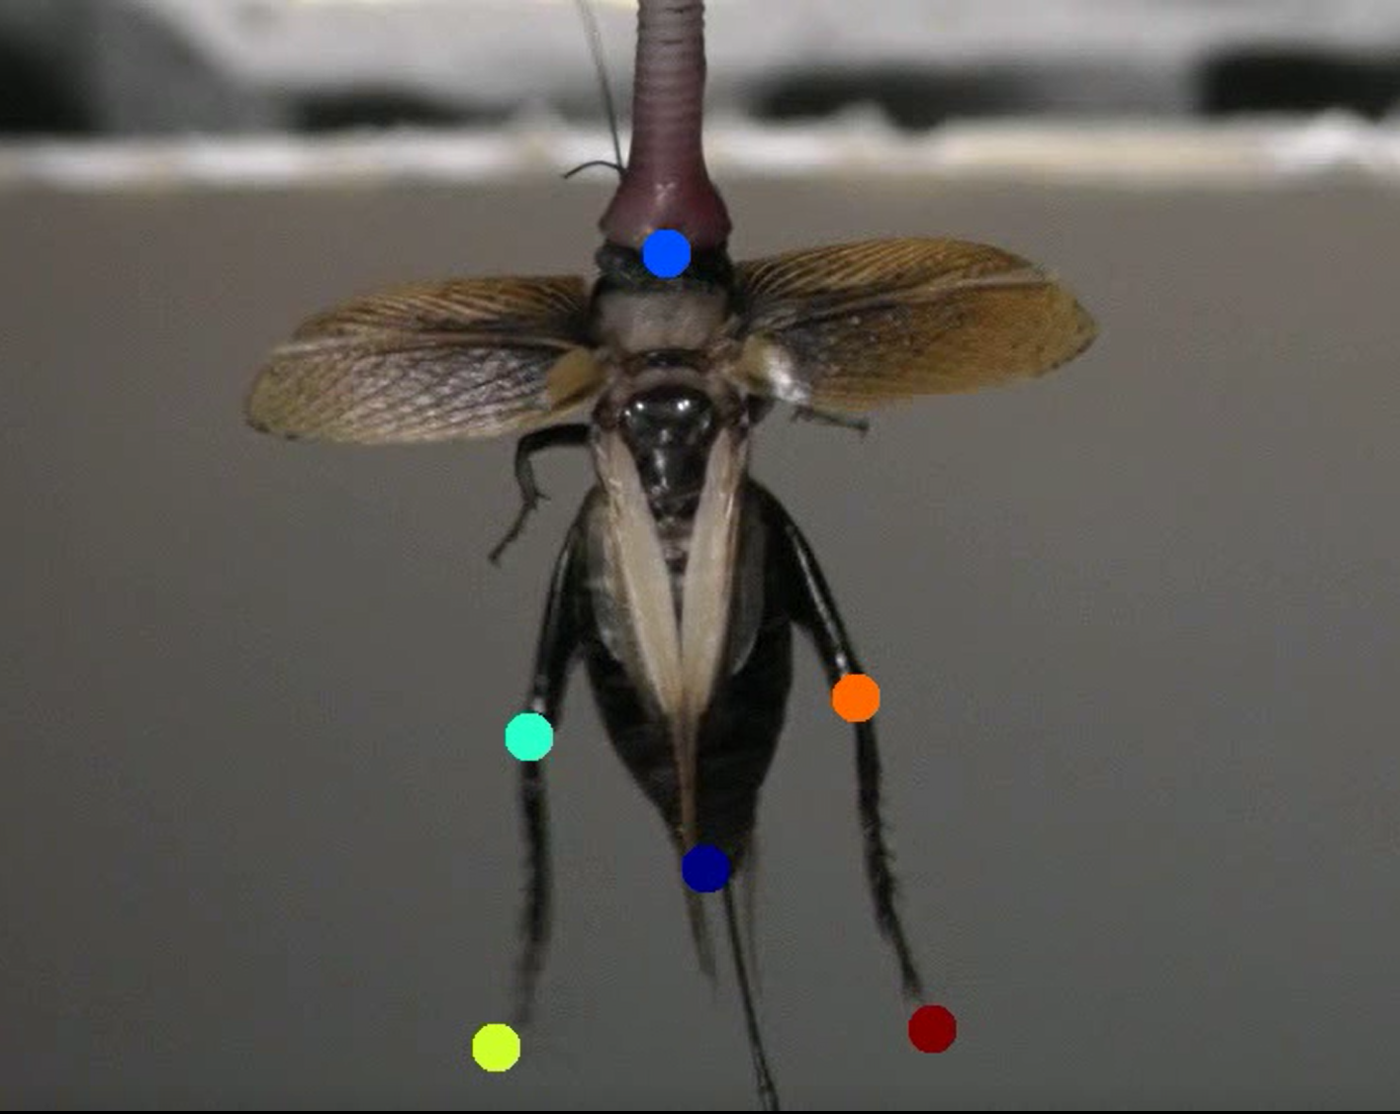\
Figure 1. Example of manually labeled frame from simulated cricket flight video. Both knees and feet were labeled, as well as the base of the abdomen and the wax fixation point.

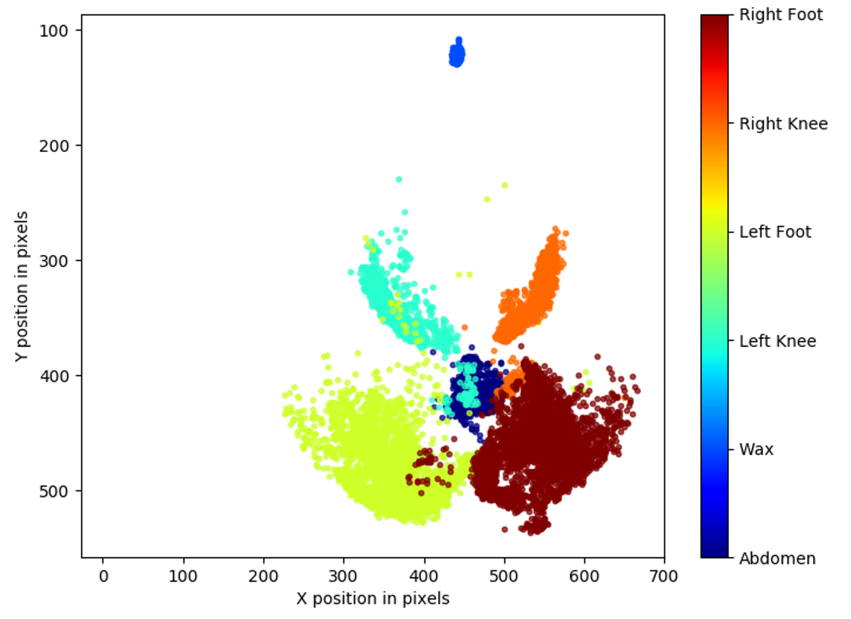
Figure 2. Example of x-y trajectory plot for DeepLabCut labeled video. Outlier points (e.g., Left Foot points that are distant from the rest of the cluster) are a result of imperfect automatic labeling on the video. Points like these like these often occurred with an increase in sporadic movements by the cricket, and can be reduced with increased training and label refinement.
Acknowledgments
This research was funded by the Maine Space Grant Consortium. Bowdoin College is an affiliate of the Maine Space Grant Consortium.
I would like to thank Professor Hadley Horch for the opportunity to work in her lab for the summer and for the guidance she gave me throughout the process. I would also like to thank Julie Scholes and Holly Wadman for their previous honors thesis work in negative phonotaxis behavior in crickets, including footage used for my work and guidance using DeepLabCut. As well, I would like to thank Professor Jack O’Brien and his research team for their work on the statistical analysis of the data collected from my work.

References
Mathis, A., Mamidanna, P., Cury, K. M., Abe, T., Murthy, V. N., Mathis, M. W., & Bethge, M. (2018). DeepLabCut: markerless pose estimation of user-defined body parts with deep learning. Nature neuroscience, 21(9), 1281-1289.

