Linking Floral Toxins to Pollinator Flight
Student Researcher: Kaya, S, Wurtzel Advisor: Patricia Jones
Bowdoin College
Department of Biology
Abstract
Pollinators interact with both naturally occurring toxins in plant nectars, pollens, and/or leaf tissue and with introduced toxins in pesticides. Many plants produce toxins in their nectar, pollen, and/or leaf tissue as a chemical defense to herbivory (Adler 2000). These toxic defense chemicals can have varied effects on different pollinators, potentially selecting for the most efficient pollinators and deterring herbivores (Jones and Agrawal 2016). Toxic floral compounds can have a range of effects on pollinator behavior, but the focus of this study is on flight. Pollinator flight ability is essential to survival for both the pollinator and the plants that depend on their ecosystem services (Tosi, Burgio et al. 2017). Floral toxins have been shown to induce a malaise with a collection of associated altered behaviors, some of which may impact flight (Ehlers and Olesen 1997, Ayestaran, Giurfa et al. 2010, Hurst, Stevenson et al. 2014). While these malaise behaviors could impact flight, few studies actually examine the effects of toxins on physiological flight ability. One 2017 study shows that a common neonicotinoid pesticide had a short term excitatory effect on and a long term reduction in flight ability (Ehlers and Olesen 1997, Ayestaran, Giurfa et al. 2010, Hurst, Stevenson et al. 2014). This study, along with the cluster of malaise behaviors, suggests that floral toxins and chemically similar pesticides impact not only behavior but also the physiological scope of pollinators, with potentially different short and long term implications. The impact of floral toxins and pesticides on pollinator flight has larger implications for ecosystem health—there is a significant gap in the literature on this topic.

Project Objectives
The objective of this project was to establish connections between toxins that pollinators come into contact with while visiting flowers and changes in pollinator flight. Pollinator flight was considered both in terms of the biomechanics of the flight itself and various flight behaviors. The ultimate objective of this project was to conduct background research in preparation for designing a biology honors thesis at Bowdoin College.

Methodology Used
The primary methodology for the summer component of this project was literature review. The literature was reviewed on topics spanning from the biomechanics of bumble bee flight to plant responses to herbivory. The literature review produced during this project will provide the background for lab experiments that will be performed during the coming spring semester.

Results Obtained
Pollinator flight
In order to fly, pollinators must generate aerodynamic forces with their wing movement that allow them to hover, turn, and move forward (Wang 2005). As an insect increases its weight or alters it center of gravity, by collecting pollen and/or nectar, the aerodynamic forces required to fly become more challenging to produce. For bumblebees, Mountcastle et al. (2015) proposes a tradeoff between flight stability and maneuverability. Bees carry pollen on their hind legs and nectar in their abdomen. Pollen-loaded bees may have more stable flight because their load is positioned further from their center of mass, while nectar loaded bees may have increased maneuverability (Mountcastle, Ravi et al. 2015). This tradeoff may impact foraging decisions in varying wind conditions or may explain changes in flight due to toxin related behaviors, such as grooming.

Toxins and pollinator behavior
Floral toxins have been shown to impact pollinator behavior in a number of different studies. One of the major hypotheses describing this phenomenon is the “drunken pollinator” hypothesis, which describes a sluggish behavior after ingesting nectar containing ethanol (Adler 2000). The same framework applies other toxins. In the honeybee, Apis mellifera, the malaise behavior consists of increased time grooming, along with difficulty with typical self-righting behaviors and unusual abdomen dragging and curling up after ingesting or being injected with a toxin (Hurst, Stevenson et al. 2014). In contrast to honeybees, fruit-wasps exhibited decreased grooming behavior after ingesting ethanol, which may increase the likelihood of pollen transfer between plants (Ehlers and Olesen 1997). Changes in grooming behavior may have important implications for flight because it alters the mass and center of mass of the pollinator, by removing weight carried farther from the center of the body.

Toxins and flight
Toxins can impact flight both indirectly, through behavioral changes, and directly, through changes in physiological flight capacity. Changes in pollinator behaviors due to toxin ingestion like increased or decreased grooming, which regulates pollen loading, could indirectly alter flight dynamics (Ayestaran, Giurfa et al. 2010, Hurst, Stevenson et al. 2014). Based on the framework established for bumblebees, increased grooming would decrease the pollen load, increasing maneuverability and decreasing stability (Mountcastle, Ravi et al. 2015). Most studies focus on the behavioral effects of toxins, but one study shows that a common neonicotinoid directly reduced honeybee flight ability (Tosi, Burgio et al. 2017). This study found that, right after exposure to the neonicotinoid, honeybees flew for longer amounts of time and further distances, but, after chronic exposure, they became slower and flew less (Tosi, Burgio et al. 2017).

Significance and Interpretation of Results
Although experimental analysis and data collection was not possible this summer, the results of this literature review provide a strong background to move forward into the experimental phase of this study. The literature review establishes a number of points of connection between floral toxins and changes in flight ability. Understanding how floral toxins and introduced pesticides affect pollinator flight is critical to protecting our changing ecosystems depend on pollinators to survive.

Figures and Charts
The figure below was taken from Tosi et al. (2017). It illustrates the device used to measure physiological changes in flight ability due to toxin ingestion. A similar flight mill will be used in the coming spring to evaluate physiological changes in flight after floral toxin or pesticide ingestion.
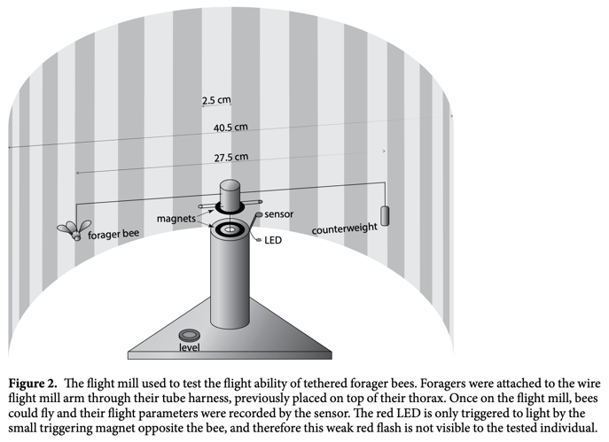

Acknowledgements
I would like to thank Patricia Jones for her flexibility, support, and guidance throughout this portion of my project, during an unusual and challenging summer, and Maine Space Grant for generously providing the funding that allowed me to begin my thesis research.

References
Adler, L. S. (2000). "The ecological significance of toxic nectar." Oikos 91(3): 409-420.
Ayestaran, A., M. Giurfa and M. G. de Brito Sanchez (2010). "Toxic but drank: gustatory aversive compounds induce post-ingestional malaise in harnessed honeybees." PLoS One 5(10): e15000.
Ehlers, B. K. and J. M. Olesen (1997). "The fruit-wasp route to toxic nectar in Epipactis orchids?" Flora 192(3): 223-229.
Hurst, V., P. C. Stevenson and G. A. Wright (2014). "Toxins induce ‘malaise’behaviour in the honeybee (Apis mellifera)." Journal of Comparative Physiology A 200(10): 881-890.
Jones, P. L. and A. A. Agrawal (2016). "Consequences of toxic secondary compounds in nectar for mutualist bees and antagonist butterflies." Ecology 97(10): 2570-2579.
Mountcastle, A. M., S. Ravi and S. A. Combes (2015). "Nectar vs. pollen loading affects the tradeoff between flight stability and maneuverability in bumblebees." Proceedings of the National Academy of Sciences 112(33): 10527-10532.
Tosi, S., G. Burgio and J. C. Nieh (2017). "A common neonicotinoid pesticide, thiamethoxam, impairs honey bee flight ability." Scientific Reports 7(1): 1201.
Wang, Z. J. (2005). "DISSECTING INSECT FLIGHT." Annual Review of Fluid Mechanics 37(1): 183-210.

