The Incidence and Potential Role of MAGUK Family Proteins in G. bimaculatus
Researcher: Hannah T. Scotch
Advisor: Dr. Hadley Horch
Bowdoin College
Neuroscience Department
Abstract
Despite other advances in neuroscience, the area of synaptic plasticity remains largely unexplored. The auditory system of the Mediterranean field cricket (Gryllus bimaculatus) is a powerful model from which we can learn about plasticity in more complicated nervous systems. However, the mechanism behind its high plasticity remains unclear. The MAGUK protein family is a group of scaffolding proteins involved in cell-cell adhesion and the formation of cell junctions, specifically synapses. This fact, along with predictions from an in-house cricket transcriptome, indicate that proteins of this family may be partially responsible for the plasticity of the cricket auditory system. To verify this, I set out to characterize the MAGUK protein family in G. bimaculatus by mining a transcriptome for MAGUK-family proteins and developing a categorized family tree of these proteins. I identified twenty-six G. bimaculatus sequences that I believe are homologs of the D. melanogaster proteins polychaetoid, stardust, varicose, metro, caki, calcium channel β, and discs large. I believe that these proteins may play an important role in the formation of new synapses as the auditory system responds to injury.

Project Objectives
Despite other significant advances in the field of neuroscience, the area of synaptic plasticity remains largely a mystery. It is, however, a concept that should be given great consideration, as understanding what drives the response of nervous systems to injury is integral in understanding the same process in ourselves. The auditory system of the Mediterranean field cricket (Gryllus bimaculatus) is an especially powerful model from which we can learn much about plasticity in more complicated nervous systems, as the cricket auditory system responds remarkably well to change. Following the loss of an ear, ascending neuron 2 (AN-2), which is responsible for responding to bat ultrasound, sends dendrites across the midline of the animal’s prothoracic ganglion (Horch et al., 2017). These dendrites then form viable synaptic connections with afferents from the contralateral ear, presumably to continue aiding in the cricket’s ability to hear and evade predators (Horch et al., 2017). However, the process by which the dendrites of AN-2 grow and connect across the midline remains to be elucidated.
The MAGUK protein family is a group of well conserved, well characterized scaffolding proteins that are involved in cell-cell adhesion and the formation of cell junctions, specifically synapses (Anderson, 1996; Zordan et al., 2005; Oliva et al., 2012). Additionally, proteins of this family, particularly caki, polychaetoid, metro, discs large, and calcium channel β (cab), have been shown to aid in the recruitment and localization of membrane-bound proteins that are essential for the proper formation of synapses (Kim et al., 1995; Martin and Ollo, 1996; Thomas et al., 1997; McGee et al., 2004; Takahashi et al., 2004; Bachmann et al., 2010; Choi et al., 2011). The strong evidence that proteins within the MAGUK family function in synapses and aid in the development of cell-cell connections, as well as predictions from an in-house cricket transcriptome that these proteins are upregulated following deafferentation, leads me to believe that proteins of this family may be in part responsible for the incredible plasticity of AN-2. In order to verify this, I set out to characterize the scope and specifics of the MAGUK protein family in G. bimaculatus, which I aimed to accomplish by mining a transcriptome for MAGUK-family proteins and developing a categorized family tree of these proteins.

Methodology Used
A literature search was performed using the NCBI protein database to isolate thirty-two characterized MAGUK family proteins in D. melanogaster. In order to find similar sequences in G. bimaculatus, these sequences were imported into Geneious (version 10.2) and used as queries for tblastn searches of an in-house G. bimaculatus transcriptome. The resulting sequences with an E value larger than e⁻¹⁰ were removed, as were duplicate sequences. The appropriate open reading frame was then translated for each BLAST hit. Reciprocal BLASTp and domain searches were then performed through NCBI on all of the remaining sequences, and sequences were removed if they did not yield reciprocal results in the MAGUK family or did not contain at least one of the three canonical MAGUK domains, which are the PDZ, SH3, and GUK domains (Anderson, 1996; Dimitratos et al., 1999; te Velthuis et al., 2007). A tree was then created with the resulting sequences and original D. melanogaster sequences using the BLOSUM-45 setting, and a second tree was made with just the original sequences and sequences containing all three of the canonical domains.

Results Obtained
After removing duplicates and Trinity sequences with no reciprocal BLAST results from NCBI, the results indicated that 147 Trinity sequences derived from the thirty-two original MAGUK D. melanogaster accessions were present in the G. bimaculatus transcriptome. Of these sequences, seventy-five were found to contain at least one of the three defined MAGUK domains (Figure 1). An additional sixteen sequences were found to contain all of the MAGUK domains, and these seem to be structural homologs of either stardust, discs large 1, CASK/CAKI, varicose, or metro, all of which are D. melanogaster proteins (Figure 2). Additionally, ten sequences appear to be homologs of cab, but they were only included in the initial tree, as cab only contains two of the canonical MAGUK domains (Figure 1).

Significance and Interpretation of Results
All of the proteins that I was able to isolate in G. bimaculatus, with the exception of stardust and varicose, play major roles in D. melanogaster in either the neuromuscular junction or synaptic development and maintenance (Thomas et al., 1997; Bachmann et al., 2001, 2010; McGee et al., 2004; Zordan et al., 2005; Wu et al., 2007; Buraei and Yang, 2010; Choi et al., 2011). Given the synaptic relevance of these proteins in D. melanogaster, as well as the similarity in sequence of these proteins and the sequences I identified, it is logical to conclude that the proteins encoded by these sequences also play a role in synaptic development and maintenance in the cricket. Additionally, indications from the in-house transcriptome that proteins of this type are upregulated in the period following deafferentation make it clear that the role of MAGUK family proteins in mediating plasticity should not be underestimated. Indeed, I believe that the sequences I characterized may be integral to the development of new synapses after the removal of the cricket’s ear. In the future, I hope to experimentally verify this belief through qPCR, immunohistochemistry, and in situ hybridization experiments.

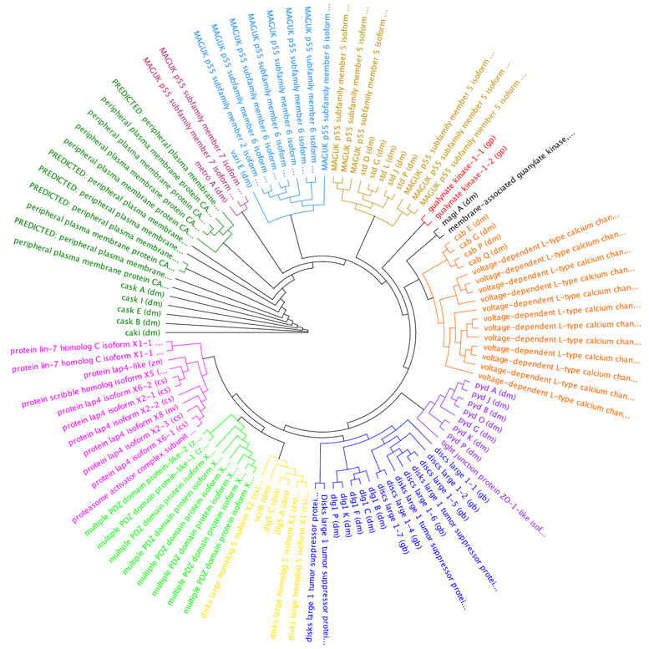
Figures

Figure 1: Tree (created using Geneious) with all original sequences from D. melanogaster, which are indicated by (dm) next to the name and all BLAST search hits with at least one of the three typical MAGUK domains (PDZ, SH3, and/or GUK). All of the BLAST hits are named according to the first result of the reciprocal BLAST performed through NCBI, an indication of the predicted nature of the protein.
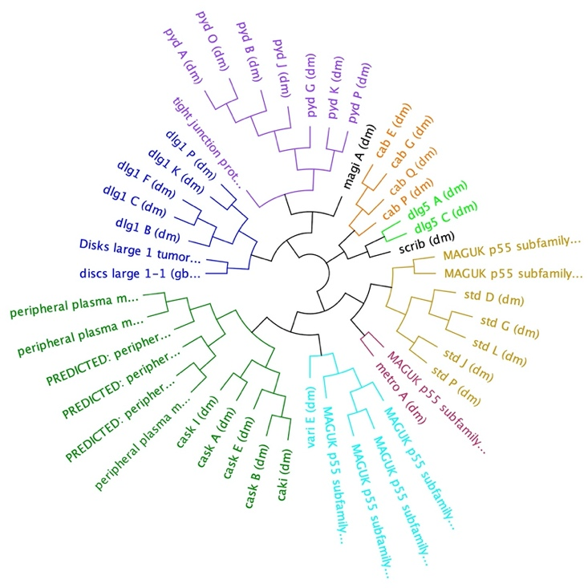
Figure 2: Tree (created using Geneious) with all original sequences from D. melanogaster, which are indicated by (dm) next to the name and all BLAST search hits containing all the three typical MAGUK domains (PDZ, SH3, and GUK). All BLAST hits were named according to the first result of the reciprocal BLAST performed through NCBI, an indication of the predicted nature of the protein.
Acknowledgements
I would primarily like to thank my research associate Emanuel Coleman for working alongside me throughout this process, and I would like to thank Professor Hadley Horch for mentoring both of us and providing us with invaluable assistance at many points during this project. I would also like to thank Justin Beckman, the lab technician in the Horch Lab, and the other members of the Horch lab for their support and assistance, as well as the Maine Space Grant Consortium for providing me with the funding necessary to complete this research.

References
Anderson JM (1996) Cell signalling: MAGUK magic. Current Biology 6:382–384.
Bachmann A, Kobler O, Kittel RJ, Wichmann C, Sierralta J, Sigrist SJ, Gundelfinger ED, Knust E, Thomas U (2010) A Perisynaptic Menage a Trois between Dlg, DLin-7, and Metro Controls Proper Organization of Drosophila Synaptic Junctions. Journal of Neuroscience 30:5811–5824.
Bachmann A, Schneider M, Theilenberg E, Grawe F, Knust E (2001) Drosophila Stardust is a partner of Crumbs in the control of epithelial cell polarity. Nature 414:638–643.
Buraei Z, Yang J (2010) The ß subunit of voltage-gated Ca2+ channels. Physiol Rev 90:1461–1506.
Choi W, Jung K-C, Nelson KS, Bhat MA, Beitel GJ, Peifer M, Fanning AS (2011) The single Drosophila ZO-1 protein Polychaetoid regulates embryonic morphogenesis in coordination with Canoe/afadin and Enabled Yap A, ed. MBoC 22:2010–2030.
Dimitratos SD, Woods DF, Stathakis DG, Bryant PJ (1999) Signaling pathways are focused at specialized regions of the plasma membrane by scaffolding proteins of the MAGUK family. Bioessays 21:912–921.
Horch HW, Pfister A, Ellers O, Johnson AS (2017) Plasticity in the Cricket Central Nervous System. In: The Cricket as a Model Organism (Horch HW, Mito T, Popadić A, Ohuchi H, Noji S, eds), pp 105–128. Tokyo: Springer Japan. Available at: http://link.springer.com/10.1007/978-4-431-56478-2_8 [Accessed January 15, 2020].
Kim E, Niethammer M, Rothschild A, Nung Jan Y, Sheng M (1995) Clustering of Shaker-type K+ channels by interaction with a family of membrane-associated guanylate kinases. Nature 378:85–88.
Martin JR, Ollo R (1996) A new Drosophila Ca2+/calmodulin-dependent protein kinase (Caki) is localized in the central nervous system and implicated in walking speed. EMBO J 15:1865–1876.
McGee AW, Nunziato DA, Maltez JM, Prehoda KE, Pitt GS, Bredt DS (2004) Calcium Channel Function Regulated by the SH3-GK Module in β Subunits. Neuron 42:89–99.
Oliva C, Escobedo P, Astorga C, Molina C, Sierralta J (2012) Role of the maguk protein family in synapse formation and function. Devel Neurobio 72:57–72.
Takahashi SX, Miriyala J, Colecraft HM (2004) Membrane-associated guanylate kinase-like properties of -subunits required for modulation of voltage-dependent Ca2+ channels. Proceedings of the National Academy of Sciences 101:7193–7198.
te Velthuis AJW, Admiraal JF, Bagowski CP (2007) Molecular evolution of the MAGUK family in metazoan genomes. BMC Evol Biol 7:129.
Thomas U, Kim E, Kuhlendahl S, Koh YH, Gundelfinger ED, Sheng M, Garner CC, Budnik V (1997) Synaptic Clustering of the Cell Adhesion Molecule Fasciclin II by Discs-Large and its Role in the Regulation of Presynaptic Structure. Neuron 19:787–799.
Wu VM, Yu MH, Paik R, Banerjee S, Liang Z, Paul SM, Bhat MA, Beitel GJ (2007) Drosophila Varicose, a member of a new subgroup of basolateral MAGUKs, is required for septate junctions and tracheal morphogenesis. Development 134:999–1009.
Zordan MA, Massironi M, Ducato MG, te Kronnie G, Costa R, Reggiani C, Chagneau C, Martin J-R, Megighian A (2005) Drosophila CAKI/CMG Protein, a Homolog of Human CASK, Is Essential for Regulation of Neurotransmitter Vesicle Release. Journal of Neurophysiology 94:1074–1083.

