Deduction Checker

Louisa Izydorczak, Class of 2020

Deduction Checker is a web application that I programmed with JavaScript and HTML for students in Professor Scott Sehon’s Introduction to Logic course to use as a resource to check their deductions. The deductions in this course are based on formal logic and allow for the use of eleven different rules including premise introduction, conversion of quantifiers, discharge, universal instantiation and existential generalization. By combining these rules, one can show how a schema or set of schemata logically imply another schema.
When a user enters a deduction, on each line they must select what rule they are using, just as they would on paper. They may also need to cite other lines and list what premise numbers their new line depends on. The deduction checker then has a function for each of the rules to check that the premise numbers, citations and schema adhere to the rule selected on a particular line.
One rule that was particularly challenging to implement was rule TF, which stands for truth-functional implication. When writing a deduction, one may use rule TF if one or more lines truth-functionally imply another line. For example, if one has as premises that if p then q and not q, then one may write not p by rule TF. The rule TF function creates an implication from the lines cited and the current line, then checks all possible assignments of true and false to ensure that the implication would come out true under every possible assignment. This process mimics writing truth tables, which is a skill students learn in the Introduction to Logic course. Evaluating whether an assignment comes out to true or false was another challenge that involved using a series of functions to take order of operations and parentheses into consideration.
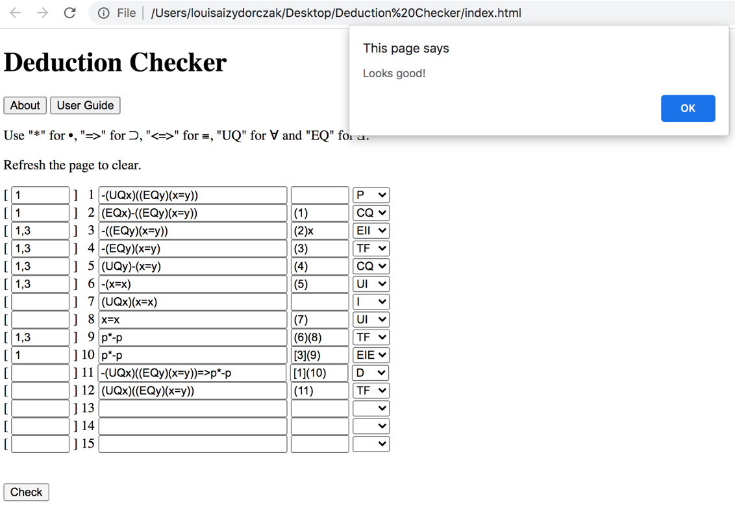
All of the source code for this project and instructions to run it are publicly available on my GitHub code-sharing account at https://github.com/louisaizy/deduction-checker.
Figure 1: A complex deduction entered into the checker shows that for every x there must exist some y that is equal to that x.

Faculty Mentor: Scott Sehon

Funded by the Gibbons Summer Research Fellowship

