Submitting Anytime Feedback
Anytime Feedback in Workday encourages employees to share positive recognition and feedback on an ad-hoc basis—unsolicited and at any time—following interactions with colleagues across departments or divisions. This type of feedback, offered by peers, managers, or fellow committee and project team members, takes place outside of formal employee check-ins and helps foster a culture of communication and collaboration.
Feedback providers can choose to recognize one or multiple employees at once. In addition to written comments, they have the option to include a “badge” icon to visually highlight the nature of the recognition. Once submitted, the feedback is immediately shared with the recipient and their manager, promoting transparency and timely acknowledgment.

Submitting Anytime Feedback for One or Multiple Employees
- Navigate to the Workday search bar and type “Give Feedback”. When the task appears in the drop-down menu, click on the “Give Feedback”.

- Enter the name(s) of the colleague(s) you’d like to provide feedback to. You can select one or multiple employees—Workday allows you to recognize several individuals at once, which is especially helpful after collaborative efforts like committee work or team projects.
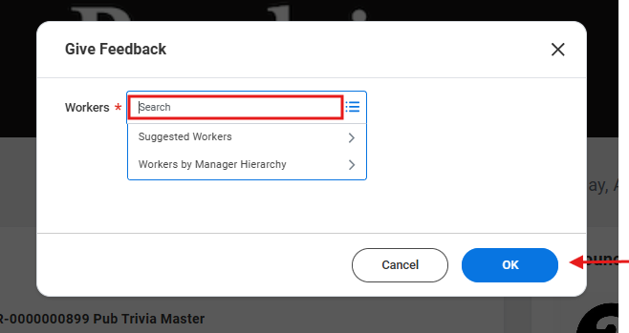
- Choose the visibility of your feedback.
  - Selecting "Share with recipient and their manager" keeps the feedback private between the individual and their manager.
  - Choosing "Share with others" makes the feedback public on the recipient’s Workday profile, allowing others in the organization to view it.
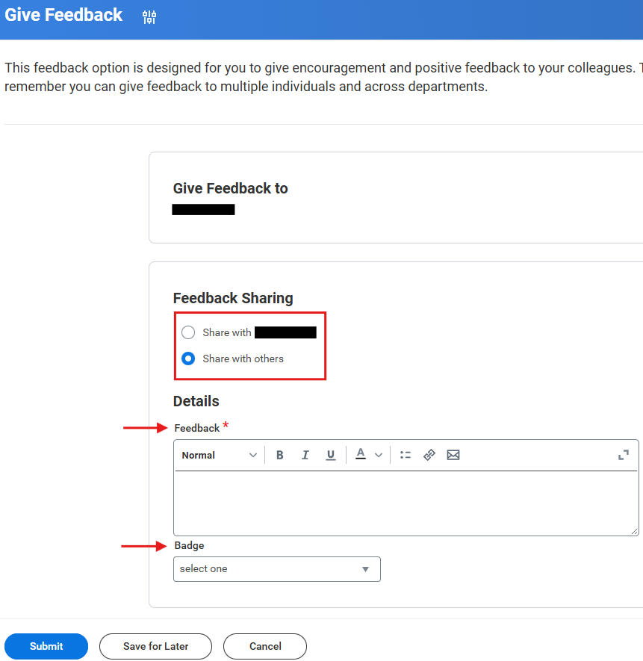
- On the Give Feedback message screen, you’ll see the list of employees you selected. Compose your feedback message, optionally select a badge to accompany the feedback, and click Submit to send.
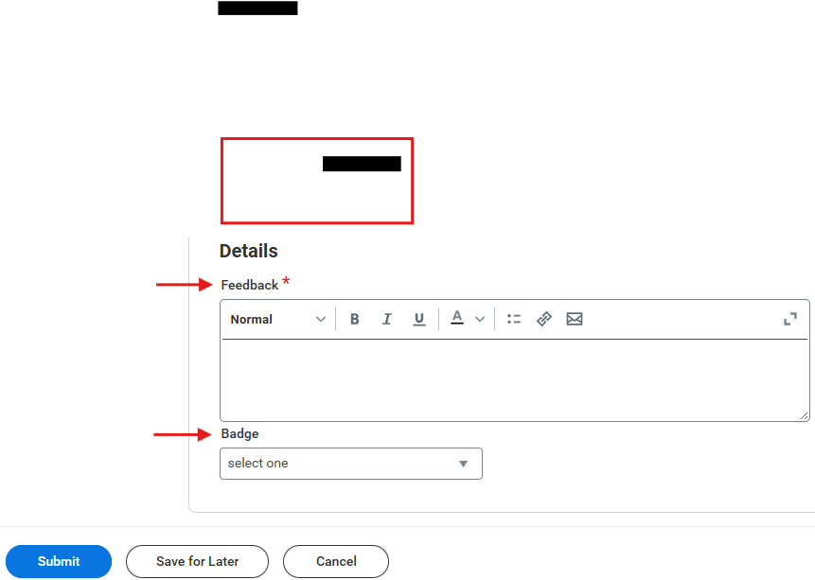
- The employees receiving the feedback—and their managers—will immediately receive a notification. They can click on the notification event to view the comments, and any badge included. If feedback was sent to multiple employees, all recipients will be noted in the message.

